**WATER LEVEL CONTROLLER**

Digital Design System Mini Project

Electronics and Communication Engineering

*Submitted by*

*Swastik srivastava – 210907352*

*Priyanshu Srivastava – 210907292*

*Deep Mala – 210907346*

*Aanjneya Mohan – 210907368*

Under the guidance of

Supervisor Name

Designation



ABSTRACT

we are building a water level controller. This system can be used in places like a house, hostels, etc. water scarcity is one of the most important global concerns. Water scarcity is the lack of water resources to satisfy water demand it can cause a severe economic crisis in a country and it has been observed by experts that it is an important global risk. Water tank overflow is a common problem leading to water wastage.

To solve this problem, the water level indicator detects and indicates the water level in an overhead tank or any other water container. In this project, we will design a water level sensor device that can detect and control the water level in a certain water container. It is a simple circuit that will detect the water level and will raise an alarm upon getting the water tank full. Whenever a tank gets filled, we get alerts.

This project water level indicator circuit typically works on the basic principle that water conducts electricity. So, water can be used to open or close a circuit. Different circuits in the controller send different signals as the water level rises or falls. These signals are used to switch ON or switch OFF the motor pump as per our requirements. The water Level Indicator is a simple low-cost circuit. There the circuit is made with various components like transistors, Resistors, LEDs, etc. This circuit is efficient and can be used for any application involving the levels of any liquid

CHAPTER 1

INTRODUCTION

1.1 Introduction:

This water level indicator can be used to indicate water overflow from any container fitted with this device*.* **The water level controller is an electronic device that detects the level of a liquid in a tank. It is used in a wide range of applications such as water and sewer services for office and apartment buildings, and industrial applications for iron and steel, food, chemical, pharmaceutical, and semiconductor industries.**

**1.2 Motivation to do work:**

Water is one of the most essential life needs. About 0.3% of the water resources in the world are usable. Water shortages already exist in many regions, with more than one billion people without adequate drinking water. This situation is one of the most important indicators of why we should be very sensitive and conscious of our water resources. As the world population increases need for water also increases. However, as a result of different effects and especially human activities, water resources are decreasing, polluted, and still used unconsciously. Therefore, it is necessary to take and implement measures as soon as possible and we must use water resources carefully. This project aims to make cheap water level controllers for residential and industrial applications.

1.3 The objective of the work:

We aimed to build a water level controller that can be used on small as well as large scales. It is handy to use and would work efficiently with any type of water container.

CHAPTER 2

2.1 BACKGROUND THEORY

Introduction:

In this, we will discuss the recent developments in the work area. We shall also cover the background theory and literature survey. The past to present state of the project shall be discussed.

2.2 Brief Background theory and literature survey:

Overflowing water from houses is often taken-for-granted. Water containers in residents and industrial areas are not switched off when filled because of no indication. As for solving this problem company started manufacturing water level indicators, but there was the problem of cost for poor people. Technology needs to be cheap so that it could reach every house.

2.3 The summarized outcome of the literature survey:

The survey found that even if there are companies manufacturing water level indicators, but still not available in every place needed. Manufacturing it at a cheap price will make it easily accessible to everyone.

2.4 General discussions:

In discussions among residents and industry owners, it is expressed that water level indicators helped them to reduce water wastage.

CHAPTER – 3

METHODOLOGY

3.1 INTRODUCTION:

In this chapter, we shall go through the prototype project that we have built to tackle the above-mentioned situations. we have also included the circuit diagram/layout for reference. We shall go through each component of our project. We will also briefly mention the tools/software that we used in this project.

3.2 Detailed methodology:

The whole idea of this experiment is to detect the liquid level in a given container. The ULN2003 IC used is connected to a rod of different lengths on one side of the IC and 3 LEDs are connected on the other side of the IC on the corresponding pins to which the rods are connected. The rod with the shortest length will light first indicating a low water level and subsequently, other rods will function according to their lengths. The buzzer is connected to the LED with the shortest rod and hence will produce sound when the liquid level has reached its maximum limit.

While we were trying to add more features to our water level indicator, we got an idea of why not add a feature that automatically switches off the motor when water start overflowing.

We used the xor gate, not gate and relay for making the auto-cut motor upon overflowing of water from the container. But it did not work out as we had planned. so we are going forward with our old idea. And because of the scarcity of time, we are not working further on our auto-cut idea.

For this project, we used cheap components like uln2003, resistors, breadboard, LEDs, wires, xor gate, not gate, and relays. Because it is widely available and every component can be easily corporated in a breadboard without additional soldering and serves our present purpose.

3.3 Extra Tools used:

Digital Multimeter – used for testing whether current is flowing through wires on connection or not.

3.4 Circuit layout:

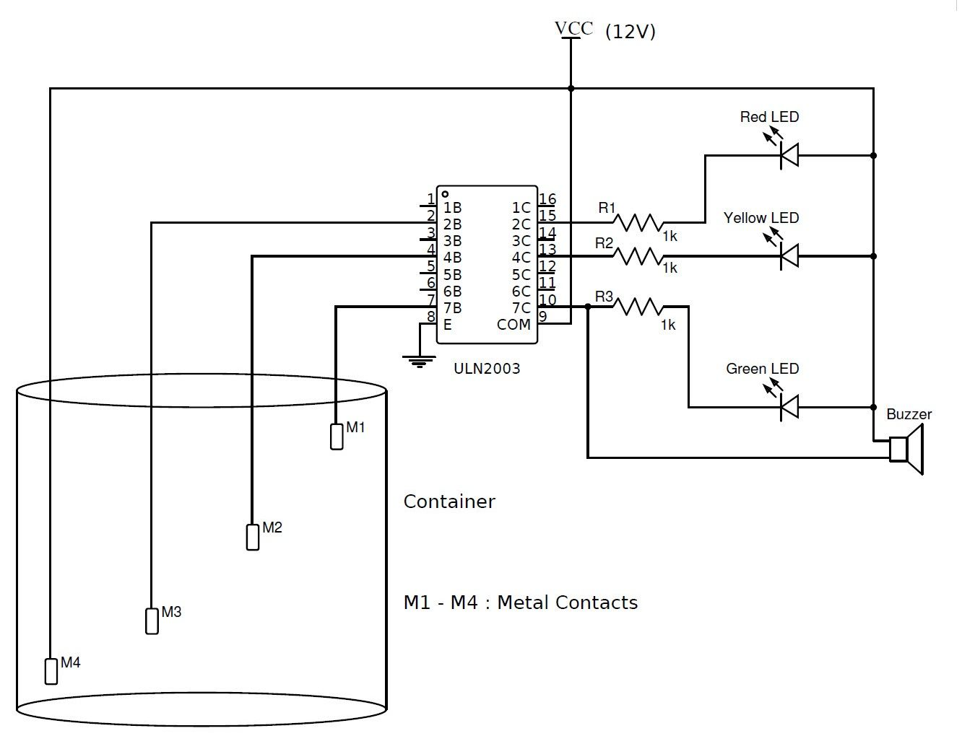

CHAPTER – 4

RESULT ANALYSIS

4.1 Introduction:

In this chapter, we shall cover the analysis of the model. We shall explain the results and also have a look into the deviations if there exist. The significance of the result shall also be given in a book.

4.2 Result Analysis:

The working of the circuit is simple. when, say, water is at its lowest level it will indicate by lighting up a lead and we will get the information that the water container is still not full when water will reach mid-level LEDs of different colors will glow up and lastly, a red led indicating overflow condition.

|  |  |
| --- | --- |
| LED | The led bulb glows corresponding to contact with the water |
| ULN2003 | ULN2003 comes with multiple functions. It has seven Darlington transistors installed which could help to control 7-Loads at the same time. |
| RESISTOR | The output is decided by this component and is used for circuit completion. |
| BREADBOARD | The other items like led switch etc are connected to the breadboard. it acts as a base. |
| CONNECTING WIRES | the wire act as a connection between other components. also used to complete the circuit. |
| BUZZER AND BATTERY | Buzzer for alarm and battery for power supply. |

4.3 Significance of the result obtained:

The metal when comes in contact with water at different water levels led bulbs of respective levels to turn on in addition to the buzzer alarm. As water acts as a conductor and completes the circuit lighting up LEDs.

CHAPTER – 5

CONCLUSION AND FUTURE HOPE

5.1 Work conclusion:

Often, we have seen water overflowing problems getting ignored because of the high price of water level indicators. Generally, water level Indicators are made of microcontrollers which are costly. we used uln2003 which is cheap, making the water level indicator very cheap and accessible to all.

5.2 Future scope:

This project can be further made into an auto-cut motor water level indicator. Many further improvements can be made to this project

6. REFERENCE

[1]. <https://microcontrollerslab.com/uln2003-introduction-pinout-example-features/>

[2].

<https://www.theengineeringprojects.com/2017/06/introduction-to-uln2003.html>

[3].

.theengineeringprojects.com/image/webp/2017/06/ULN2003-Datasheet-Pinout-Circuit-Diagram-Proteus-Simulation.png.webp?ssl=1